Project report of a community doctor

Submitted By:
Alam Shahriar 162-15-8179
Sadiqur Rahman 162-15-8181
Alim-Ul-Alam Masum 162-15-8227
Zarif Ahmed 162-15-8219

I. Abstract—
Community doctor is a sector that influences the doctor of all around the country to take a seat ahead and work relentlessly for the rural people and unpriviliged people.In this process the patients are less harassed and the whole system is not going to delayed any more like it was before.

II.Tools:
Visual studio as code editor.
Microsoft SQL Server Management Studio for Database Connectivity
III. Objectives:
- Creating more opportunities for the rural patients.
- Making the whole process time and cost efficient for the patients.
- Giving much relief and creating less harassment for the patients.
- Giving much access to the doctors for reaching out to the patients.

IV. Description:
A community doctor refers the patient to the hospital. The hospital checks the patient’s name, address, date of birth, and patient number in its patient file. Each hospital admission is known as an admission episode; it begins with
a reason for admission and a planned admission date being recorded when a community doctor refers the patient.
The patient is sent an admission card and this card is copied to the community doctor.
Each admission episode ends when the patient is discharged; the reason for discharge and the discharge date are recorded on the admission-episode file.

Submitted to:
Subroto Nag Pinku
Lecturer
Department of Computer Science & Engineering
Daffodil International University

The community doctor is sent discharge notes prepared by the hospital doctor.
The patient receives discharge advice. A hospital doctor supervise each admission episode and a hospital doctor supervises many admission episodes.
The hospital doctor reports any treatment that is to be undertaken by the patient and this is recorded for the episode.
When the hospital doctor makes a diagnosis, the description of the diagnosis and the diagnosis code is written on the patient file with the date; over time a patient can have may diagnoses recorded.
Each admission episode entails the possibility of treatment for the diagnosis. The treatment can be composed of surgery, medication, or both.
For surgery the date of the surgical operation, the surgery code, and a description is recorded.

An admission episode is created when a community doctor refers the patient; this called a planned admission.
If the community doctor reports that the patient’s circumstances have changed(for example as the patient recovers) then the admission can be cancelled and this becomes a cancelled admission; the cancellation date and reason are recorded.
Based upon reading the patient details, the hospital doctor offers a planned admission date to the patient.
If is advised of the delay as s the community doctor; the length of delay is recorded. A delayed admission can be cancelled.
When a patient enters hospital the admission is regarded as being activated and the admission date recorded.
If no diagnosis is made or if the diagnosis is not treatable /then the patient is discharged from ; the admission episode is completed and called a discharged admission. If the patient has treatable diagnoses then the admission is regarded as treatable and the admission episode is marked accordingly.
While different treatments are carried out the admission continues to be called treatable.
When the treatment cycle is completed the patient is discharged; the discharge date and reason for discharge are written on the episode. The discharge is the final state of admission episode.
There are two types of doctor involved in the care of a patient.
Both types of doctor have a doctor number, a medical qualification, and a name the hospital doctor supervises each admission episode and is responsible for discharging the patient.
For the hospital doctor we record the ward /clinic and especially the doctor is responsible for .
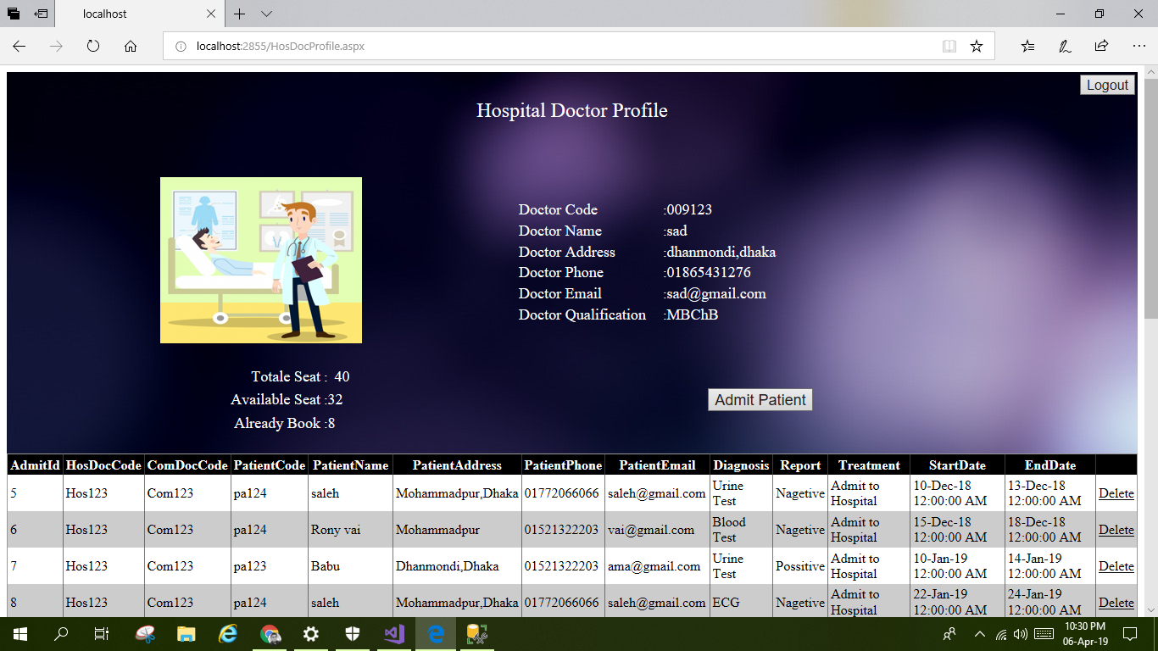
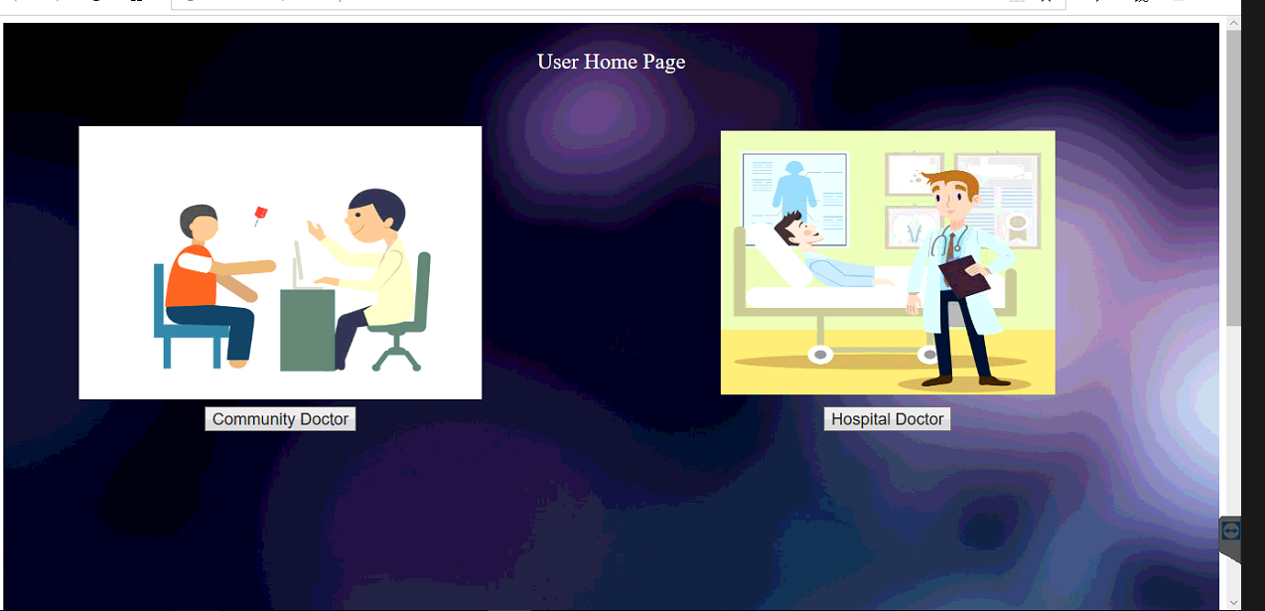
The community doctor refers the patient in the first place for the community doctor we record the practice address, postcode, telephone number, and fax number.
A hospital doctor can never be a community doctor as well .
V. Snapshots:
VI. Conclusion: This project can prove to be very helpful for older unprivilaged people. This system ensures that the patients are less harassed and also makes sure the get the best treatment available.
